
Poster Contest Theme:
THIS COMPLETED FORM MUST BE ATTACHED TO THE BACK OF THE POSTER
“Soil. Where It All Begins.”
DEADLINE: Wednesday, April 8, 2026, by 4:00 PM
Please Check the Appropriate Contest “Grade” Category:

K-1st 2nd-3rd 4th-6th 7th-9th 10th-12th

PLEASE PRINT LEGIBILY

STUDENT’S NAME

First: _________________________ Middle: _____________________ Last: ________________________________ Address: _____________________________________________________ Student’s Age: _____ Grade Level: _____
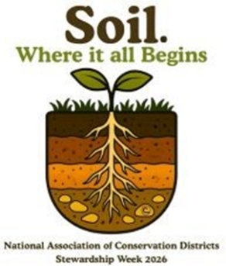
Address needed to receive awards.

Please Circle “Yes” or “No”:

Artwork is an original piece completed by the student listed above: Yes / No

Student received assistance from another person: Yes / No

Materials/ideas received from another source: Yes / No

If any question listed above was circled “Yes”, please explain:

____________________________________________________________________________________________________________________________________________________________________________________________________________________________________________________________________________________________________________________________________________________________________________________

Parent/Guardian’s Full Name, Printed: _______________________________________

PARENT/GUARDIAN SIGNATURE: ___________________________________________________ DATE: ____________

Email: ___________________________________________________Phone Number: (____)__________________
Signature allows Conservation Districts to utilize student’s submission for educational or promotional purposes.

SCHOOL INFORMATION
Please Check the Appropriate School Category: Public Private Home

School Name: _________________________________ Contact Person: __________________________________

Address/Email: ____________________________________________ Phone Number: (____)__________________

CONSERVATION DISTRICT

District Name: _________________________________ Contact Person: __________________________________

Address/Email: ____________________________________________ Phone Number: (____)__________________

